Introduction to the problem

Taken from: http://www.internalcontrolsdesign.co.uk/rating/index.html

This page is for people who want to learn how to come to a rational conclusion when posed with some difficult decisions about an uncertain future (= risk assessment and management).
Coming up with something logical and practical is hard. Partly this is because quantifying risks is hard. Often there is little data to back up gut feeling.
- A risk may be something for which there is no relevant history.
- Gut feeling is notoriously unreliable.
- Other problems include the fact that risks combine in ways that are difficult to think about and quantify

Despite this, amazing things can be done by very intelligent people, backed by extensive empirical data and computers, to quantify and visualise risks, often discovering things intuition did not bring to light. Unfortunately, in other settings this sophistication is not available or hard to justify.
Many risk ratings are done by asking groups of people to make subjective ratings and many of these are fundamentally flawed.

What is Risk?
Taken from: http://gridreliability.nist.gov/Workshop1/SiteAssessment.pdf accessed 13.4.2008 2014h; Joe Higgins Staff Engineer Sun Labs, Robert Sewell Senior Staff Engineer, Sun Microsystems
We associate the word “Risk” with something that has a chance of producing an adverse outcome
- What can go wrong?
- How likely is it?
To understand Risk, we need to be able to:
- Identify the various scenarios leading to adverseoutcomes
- Assess the scenario consequences/outcomes
- Assess the scenario likelihoods

The Concept of Risk | Goal of Risk Management: Reward-Risk Target
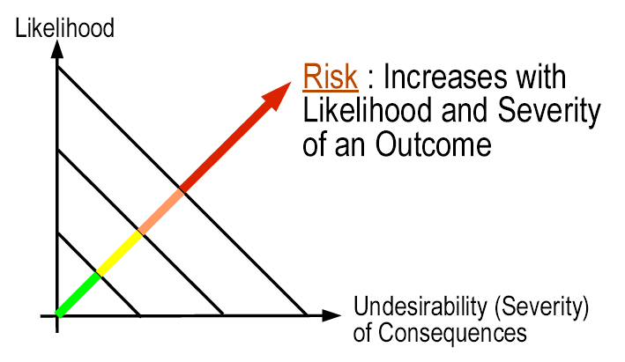 | 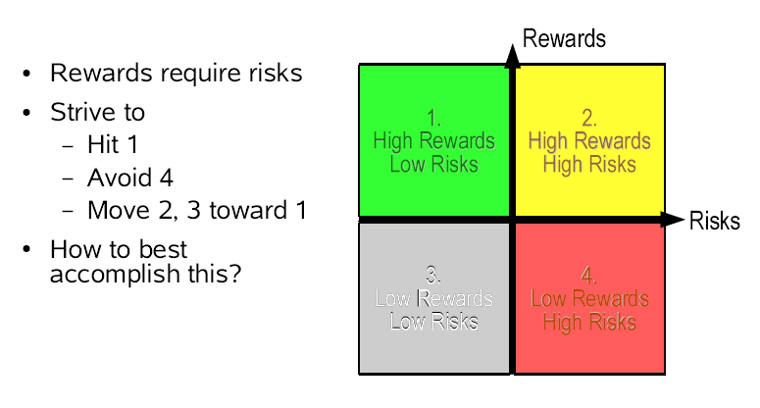

Communicating Risk:
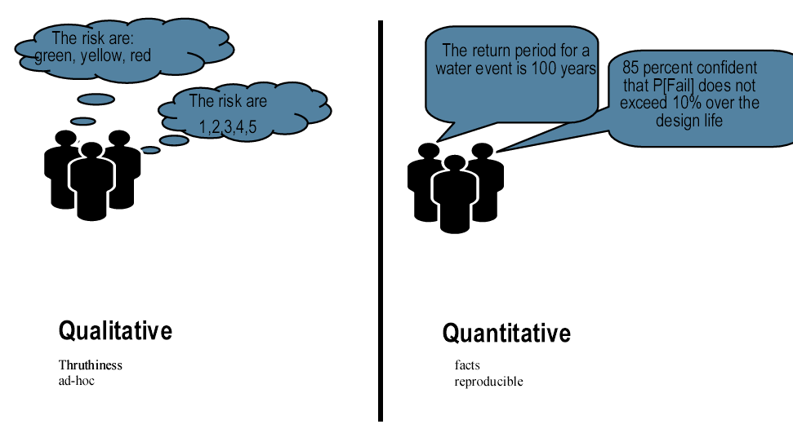

Generalized Approach to Risk Quantification
For each unscreened hazard/risk:
- Identify a complete set of possible adverse scenarios (not every outcome will be a catastrophe, but work out the range)
- Quantify consequences of each scenario
- Quantify likelihoods of each scenario

Examples of Catastrophe Risk
Fire, Earthquake, Flood, Tornado. Airplane Crash
Etc
Okay, so you it’s unlikely that what you’re involved with is anything as big as these. But even in your organisation, there can be near-catastrophic outcomes for that organisation. Work out what these might be.

Risk Quantification
Now decide if risk is acceptably low, and if not, what is the most effective risk mitigation strategy
Decide on a design that explicitly achieves a desired safety or reliability level
Then monitor the system; something like this is what you should be thriving towards:

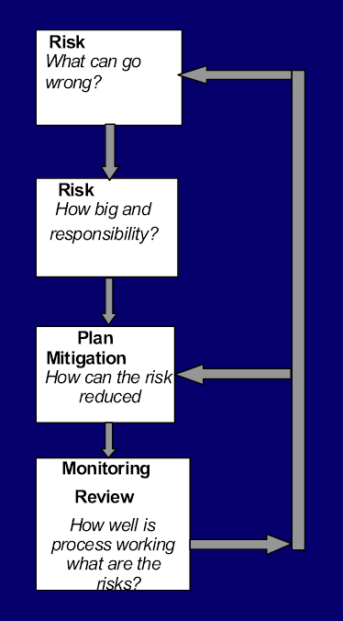

If there is a controversy, how do you know which side to believe? What if I told you I had a way where you don’t need to believe anyone but you could still decide with confidence what you should do.

There are two things you need to remember
- Firstly no one is perfect – so every choice you make brings with it a risk if that choice turns out to be a mistake
- Given that, which risk would you rather take?

- Listen to the activists and take big action now, risking possible harm to the economy that the activitsts warn us about; or listen to the sceptics and don’t take big action now risking the possible destruction and upheaval the activists warn us about?
- The bottom line is, which is the more acceptable risk? The risk of taking action or the risk of not taking action?
- If you need to make a decision when things are unclear, like with global warming, its often useful to look at the different possibilities for the future. The first possibility to consider the possible .
- A common problem in project risk management processes is the need to determine the relative significance of different sources of risk so as to guide subsequent risk management effort and ensure it remains cost effective.
- A common approach is to rank risks in terms of probability and impact to identify sources of risk which will receive the most attention. This paper examines the shortcomings of this technique in guiding the analysis and management of risks and considers the information needed for a proper assessment of importance. For cost-effective management it is desirable to distinguish not only between the size of impacts and probability of impacts occurring, but also other factors such as the nature of feasible responses, and the time available for responses. The paper offers some practical suggestions for dealing with this problem.
- Upon identifying the magnitude/extent of risk impact and likelihood for each risk categories / operational processes, the magnitude of each of the 4 risk categories / operational processes are mapped into a Risk Quadrant Grid.

3. Risk Quadrant
From the risk assessment, the risk categories (e.g. people risk) or the operational processes (e.g. cash receipt/payment over the counter) are mapped into the Risk Quadrant Grid. The Grid is divided into the following four quadrants :-

Quadrant Risk Assessment
(i) Significant Impact and High Likelihood - High Risk
(ii) Significant Impact and Low Likelihood - Medium-High Risk
(iii) Insignificant Impact and High Likelihood - Medium-Low Risk
(iv) Insignificant Impact and Low Likelihood - Low Risk

Insignificant Impact-High Likelihood  Medium-low risk | Significant Impact-High Likelihood  High risk
Insignificant Impact-Low Likelihood  Low risk | Significant Impact-Low Likelihood  Medium-high risk

Likelihood
Taking account of the controls in place and their adequacy, how likely is it that such an incident/situation could occur?

Score Descriptor Description
5 Almost Certain Likely to occur on many occasions
4 Likely Will probably occur, but is not a persistent issue
3 Moderate May re-occur occasionally
2 Unlikely Do not expect it to happen again but it is possible
1 Rare Can't believe that this will ever happen

Consequence
Taking account of the controls in place and their adequacy, how severe would the
consequences be of such an incident/situation?

Score Descriptor
- Actual or Potential - Impact on the Individual
- Actual or Potential - Impact on the Organisation
- Number of persons affected
- The potential for Complaint/Litigation

Catastrophic
DEATH (eg Toxic offsite release,multiple deaths any other cause) (eg cervical screening disaster,evacuation)
National adverse publicity.
WAG investigation
Litigation certain/expected

Major
PERMANENT INJURY (eg loss of body part, misdiagnosis with poor prognosis, long term sickness, loss of specimens)
Service closure
RIDDOR reportable
Litigation certain/expected

Moderate
SEMI-PERMANENT INJURY/DAMAGE (eg injury taking up to 1 year to resolve)
Needs careful PR handling
RIDDOR reportable
MDA reportable
Litigation possible but not certain
High potential for complaint

Minor
SHORT TERM INJURY/DAMAGE (eg injury that has resolved within 1 month)
Minimal risk to the organisation
Complaint possible
Litigation unlikely

None
NO INJURY OR ADVERSE OUTCOME
No risk to the Organisation
Unlikely to cause complaint
Remote risk of litigation

Control Self-Assessment (CSA)
Finally, the CSA questionnaires are formulated on the high risk and medium-high risk quadrants.

Probability/Impact Grid™ - Group Decision Support System

http://www.eresultants.com/probability_impact.htm accessed 13.4.2008 2020h
Probability/Impact Grid is a powerful new tool to help a group understand risk in a project.

Probability / Impact Grid™
The Probability / Impact Grid™ is the key tool for risk assessment. Each participant is asked what he or she believes the likelihood is of a particular risk (or event) occurring. They are then asked what they think the impact would be if the risk (or event) occurred. The keypad system provides a very rapid means by which to gather opinions from all involved in the discussion.

The probability vs impact assessment is carried out for each risk in turn. For each risk element, the result of this process is a visual representation illustrating the spread of opinion among those present. If you have consensus, then you may have confidence in action. If the results of the probability/ impact assessment show that you do not have consensus, then time can be devoted to further discussion of the issues involved. The software can then be used to re-evaluate the risks, where differences of opinion emerged. The Probability/Impact Grid™ allows you to capture explanations, consequences and commentary that emerge from the ensuing discussions.

The Probability / Impact Grid™ is very useful in determining how much effort you should put into discussing and planning around an issue. Risks will tend toward one of the following:

Probability/ Impact | Low impact | High impact
High probability | Although likely to happen, the low impact means that you can take small steps to ensure it does not affect operation. | This is a high-risk issue, and needs careful planning and consideration.
Low probability | Little consideration is needed of this risk. | You need to identify signs that this is going to happen, so that you can plan appropriate action should it occur.

To illustrate the matrix assessment tool, we will consider the probability / impact grid, which is the key tool for risk assessment. Each participant is asked what they believe the likelihood is of a particular risk (or event) occurring. They are then asked what they think the impact would be if the risk (or event) occurred. The keypad system provides a very rapid means by which to gather opinions from all involved in the discussion. The probability verses impact assessment is carried out for each risk in turn. For each risk element, the result of this process is a visual representation illustrating the spread of opinion. If you have consensus, then you may have confidence in what actions to take. If the results of the probability/ impact assessment show that you do not have consensus, then time can be devoted to further discussion of the issues involved. The software can then be used to reevaluate the risks, where a differences of opinion emerged. If you are using Decision Explorer® (rather than manually entering a list of elements - risks or events - for consideration) then, when differences of opinion emerge, you can elaborate your Decision Explorer® model with the explanations, consequences and commentary which emerge from the ensuing discussions.

The probability / impact assessment is very useful in determining how much effort you should put into discussing and planning around an issue. Risks will tend toward one of the following:

Probability/ Impact | Low impact | High impact
High probability | Although likely to happen, the low impact means that you can take small steps to ensure it does not affect operation. | This is a high-risk issue, and needs careful planning and consideration.
Low probability | Little consideration is needed of this risk. | You need to identify signs that this is going to happen, so that you can plan appropriate action should it occur.

The matrix facility is used to:
- Gather a two-dimensional assessment of options / ideas / events
- Give a qualitative indication of elements which (particularly in a risk setting) may need to be quantitatively analyzed.

In use
http://www.banxia.com/impact/matrixmode.html

